IN THE LABOUR COURT OF ZIMBABWE

HARARE, 06 MARCH, 2024

07 MARCH 2024
JUDGMENT NO LC/H/95/2024 CASE NO R-LC/H/169/23

MICHAEL CHITEKA APPLICANT

BINDURA NICKEL CORPORATION LIMITED RESPONDENT

Before the Honourable G. Musariri, Judge:

For Applicant - Ms V.C. Maramba, Attorney
For Respondent - Mr F. Mahere, Attorney and
- Mr T.P. Donzwambeva, Attorney

MUSARIRI, J:

At the onset of oral argument in this Court Respondent made an oral application for upliftment of bar and condonation of its belated Response. The application was made in terms of Rule 29(a) of the Labour Court Rules S.I. 150 of 2017. Applicant opposed the application.

Background
- On 9th March 2023 applicant filed the present application for leave to appeal to the Supreme Court of Zimbabwe.
- Applicant then filed a Certificate of Service indicating that the application had been served upon respondent’s attorneys on the 16th March 2023.
- On 23rd March 2023 respondent timeously filed a Notice of Opposition.

- The notice was accompanied by an affidavit deposed by one Design Masiya.

- On 11th April 2023 applicant filed his Heads of Argument.
- The heads applicant pointed out that Masiya’s affidavit was improperly commissioned, thus there was no valid opposition to the application.
- On 14th April 2023 respondent filed its Heads of Argument.
- In the heads, respondent conceded that Masiya’s affidavit was improperly commissioned.
- Respondent further stated that it will make an oral application for condonation of a new opposition.

Respondent indicated that once it was alerted to the defect in its opposition it quickly acknowledged same and filed a properly commissioned affidavit. At the same time it forewarned applicant that it shall make an oral application for condonation of the new opposition which had been filed out of time. There was little prejudice to applicant.
Applicant opposed the respondent’s application on 2 grounds.
Firstly applicant argued that a party seeking condonation must explain the reason for non- compliance and the delay in seeking condonation. In casu respondent became aware of the non- compliance on receipt of appellant’s heads on 11th April 2023. The application for condonation has been made in March 2024 almost one (1) year later. There is no satisfactory explanation for the extended delay.
Secondly applicant argued that the new affidavit is also non-compliant as it bears the 2 stamps from different attorneys.

Analysis
Respondent acted promptly in acknowledging its error and seeking to correct the error. However its efforts in effecting necessary correction came short. It should have filed a proper application for condonation which would enable applicant a reasonable opportunity to respond. Waiting for a year to make an oral application, though forewarned, was inexcusable. It smacks of an assumption that condonation would not be opposed or would be easily granted. As the superior courts have consistently pointed out, condonation is not for the asking.

It should be properly and promptly sought. This is not a case where the interests of justice call for condonation. The Court is fortified in this view by the case of

Bastin v Madzima SC 37/20 Per Mathonsi JA P 7
“Where a party has not sought condonation for failure to comply with the rules, it must give an acceptable explanation not only for the delay, but also the delay in seeking condonation.
It means what calls for some acceptable explanation is both the failure to abide by the rules and the failure to seek condonation.”

Respondent made a belated counter that applicant’s attorney had no right of audience not having filed an Assumption Agency. What respondent overlooked was that it had a limited right of audience only to motivate its application for condonation and upliftment of bar. Having failed to convince the Court to uplift the bar its argument about right of audience is out of order.
The net result is that applicant’s application for condonation stands as unopposed. It shall be granted on that basis.

Wherefore it is ordered that,

  - The application for condonation be and is hereby granted;

Applicant may file his application for leave to appeal in terms of Section 92 F(2) of the Labour Act Chapter 28:01 as read with the Labour Court Rules S.I. 150 of 2017 within ten (days) of this order; and

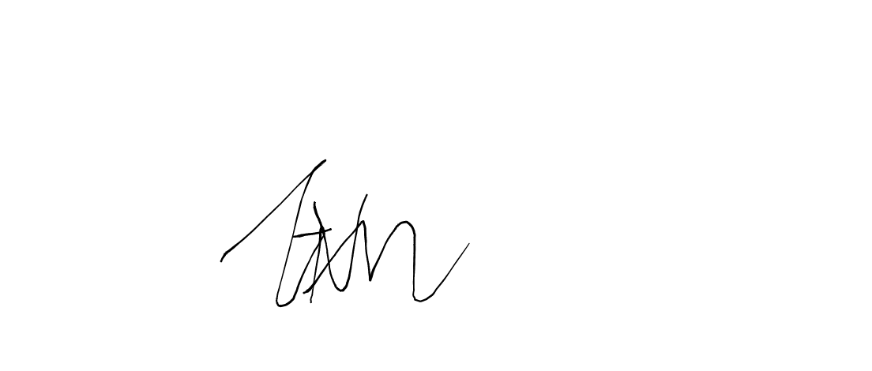
  - Each party shall bear its own costs.

G. MUSARIRI J-U-D-G-E

