IN THE LABOUR COURT OF ZIMBABWE HELD AT HARARE 23RD JANUARY 2024 AND…2024
In the matter between
JUDGMENT NO. LC/H/116/24 CASE NO. LC/H/773/23

HIPPO CREEK INVESTMENTS (PRIVATE )LIMITED APPLICANT
And
MUCHAMBO KURUNI 1ST RESPONDENT
RENIAS MKOCHO 2ND RESPONDENT
MIKE KAUNDRA 3RD RESPONDENT
JOHANE KUMBANE 4TH RESPONDENT
EMMANUEL ZENGENI 5TH RESPONDENT
SOLOMON DHAKA 6TH RESPONDENT
HARDLY TATENDA MUNEMO 7TH RESPONDENT
STANELY CHIKWAMBA 8TH RESPONDENT
JOHN MUNEMO 9TH RESPONDENT
GIVEN MBANGA 10TH RESPONDENT
MACDONALD VERENGERA 11TH RESPONDENT
DOMINGO POLOVALE 12TH RESPONDENT
TAPIWA GOTA 13TH RESPONDENT
PRIVILEDGE POLOVALE 14TH RESPONDENT
BERNARD CHIRUME 15TH RESPONDENT
GARSIKAI ZVAMATSI 16TH RESPONDENT
PERTER CHIKANGO 17TH RESPONDENT
TAPIWA GONYE 18TH RESPONDENT
STEWART 19TH RESPONDENT
TAWANDA GONYE 20TH RESPONDENT
RANGARIRAI MUGOMBI 21ST RESPONDENT
SIFELANI MACHE 22ND RESPONDENT
ENOCK MUPANDE 23RD RESPONDENT
ISAAC TICHAONA 24TH RESPONDENT

MAXWELL PASHI 25TH RESPONDENT
RICHARD CHAPWANYA 26TH RESPONDENT
TAFADZWA KUVAREGA 27TH RESPONDENT
MENFORD MUYEMEKI 28TH RESPONDENT

BEFORE THE HONOURABLE MAKAMURE JUDGE

FOR THE APPLICANT : MR G. NDLOVU (LEGAL PRACTITIONER)
FOR ALL THE RESPONDENTS: MR P. TICHAONA (LEGAL PRACTITIONER)

MAKAMURE J:
This is an application for rescission of a default judgment entered against the applicant.
Preliminary points.
Before the application was heard preliminary points were raised on behalf of the respondents. The first point was that the applicant is abusing process. It was argued on behalf of the respondents that the applicant failed to appear when it was supposed to do so. The respondents also raised as a second issue, the point that the applicant failed to timeously file the notice of response in the main matter and for this reason it was argued that the applicant was barred. On this second issue I must point out that the application before me is for the rescission of a default judgment and not the main matter. It would therefore be inappropriate for the me to consider issues to do with the main matter which is not before me ,even before the question of the default judgment has been resolved. In response it was argued on behalf of the applicant that the respondents are conflating different processes that is, rescission , upliftment of bar and condonation. It was submitted that the respondents cannot be allowed to mix them all . I agree. The application for rescission of judgment must be considered first in order for parties to chart their way forward.
In the case of NMB Bank v Tawanda Mushayi and Four Others SC82/22 the Supreme Court discouraged dealing with matters in a piece meal fashion. This delays finality to litigation. Ndebele v Ncube 1992(1) ZLR 288.Thus I find that it is the respondents who are abusing process by raising issues which do not point towards the resolution of the matter on the merits. It is correct that the applicant was in default. This is why an application for rescission of judgment has been made. The only way that the applicant can move on is to apply for the rescission of that default judgment. It can therefore not be an abuse of process. In view of this I find that there is no merit in the preliminary points raised.
Merits

It is trite that, in an application for rescission of judgment , the applicant has to meet certain requirements. These include explaining the extent of the delay, the reasonableness of the default and the prospects in the main matter . In Songore v Olivine Industries (Pvt) Ltd 1988 (2) 210 (SC) the Supreme Court stated (Headnote):

‘…the impression must not be given that the Rules may be flouted with impunity or that rescission of a default judgment given in such circumstances will be granted on request. An acceptable reason must be given for the delay. A defendant who admits that he was negligent in his tardiness may nonetheless be granted rescission if he shows bona fides; indeed the court might be unjustified in condemning him for a very short delay , although his explanation for it is inadequate, if the defendant were found to be acting bona fide and had a prima facie defence.’

The erstwhile legal practitioner for the applicant, Mr G.T. Makings, received notification that the main appeal was set down for hearing but when he checked he could not find the matter in the IECMS which system had recently been introduced. This led him not to attend court on 14th September 2023. This resulted in a default judgment being entered against the applicant. Hence the present application. This is what he stated in his affidavit (partly):
‘3.I confirm that I received a notification in the IECMS system that the main appeal under case number LC/H/285/23 had been set down for the 14th of September 2023.
- This was surprising as the condonation application in LC/H/470/23, had been argued a few months earlier and judgment had not yet been handed down. In my reasonable view as a legal practitioner, the main appeal could not be heard until the condonation application was heard . The two were inseparable.
- I enquired with the Registry whether there was a judgment in the condonation application which I was not aware of and was advised that the judgment had not yet been handed down.
- When I went back to the system to check the hearing date for the main appeal I could no longer find the notification. I then reasonably assumed that the Registrar had noted the above error that the main appeal was not yet ready for set down and had accordingly withdrawn the appeal.
- I must at this point also mention that the judgment in the condonation was only handed down after the 14th September 2023, that is to say on the 20th September 2023, a week after the appeal was heard, which in my respectful view was irregular.
- So confident was I that the notice of hearing had been withdrawn, that I wrote not one but two emails to Mr Sadomba of Gill Godlonton and Gerrans who was now taking over the matters advising him that the notice of hearing for the main matter slated for the 14th September 2023 had been withdrawn. I attach hereto my two emails to that effect dated 11th of September 2023 …’
It is clear from the affidavit by Mr Makings that he was following up the progress of the matter(s) diligently. In the normal course of proceedings an application for condonation is determined before the main matter is heard. In the present matter the main matter was heard before judgment in an application for condonation had been handed down . That was irregular. The position which Mr Makings took after failing to find notification of the appeal

matter was in my view reasonable. This is because it could be that the Registrar was now, after Mr Makings had communicated, waiting for judgment in the condonation application so that the appeal could be properly set down at a later date. Unfortunately, this was not the position of the Registrar. This I think is mainly because the IECMS system was new and a few challenges and miscommunications could have occurred.
In view of the explanation by Mr Makings I find that it was reasonable after failing to find the notification to believe that the notice of set down in the appeal matter had been withdrawn.
The default was therefore not deliberate. Obviously, the position was that the notice of hearing had not been withdrawn and the matter remained on the roll with the hearing being conducted in the absence of the applicant or its legal practitioners. This led to the present application.
On the question of prospects of success, the facts which are not disputed are that the respondents raised a claim for underpayment of wages by the applicant. The matter was heard by a designated agent. The Designated Agent dismissed the claim on the basis that the applicant was exempted from paying the wages so claimed by provisions of Statutory Instrument 152/1990. Whether or not the Designated Agent was wrong in dismissing the claim(s) in question can only be determined after the parties have been heard on appeal. This means that there are prospects of success on appeal.

In view of the foregoing the applicant has discharged the requisite onus on a balance of probabilities. The application succeeds.
It is accordingly ordered that :

- The application for rescission of judgment be and is hereby granted .
- The Order granted by this Court in case number LC/H/285/23 on14th September 2023 be and is hereby rescinded.
- The Registrar be and is hereby directed to set the appeal case number LC/H/285/23 for hearing on the next available date.
- There is no order as to costs.

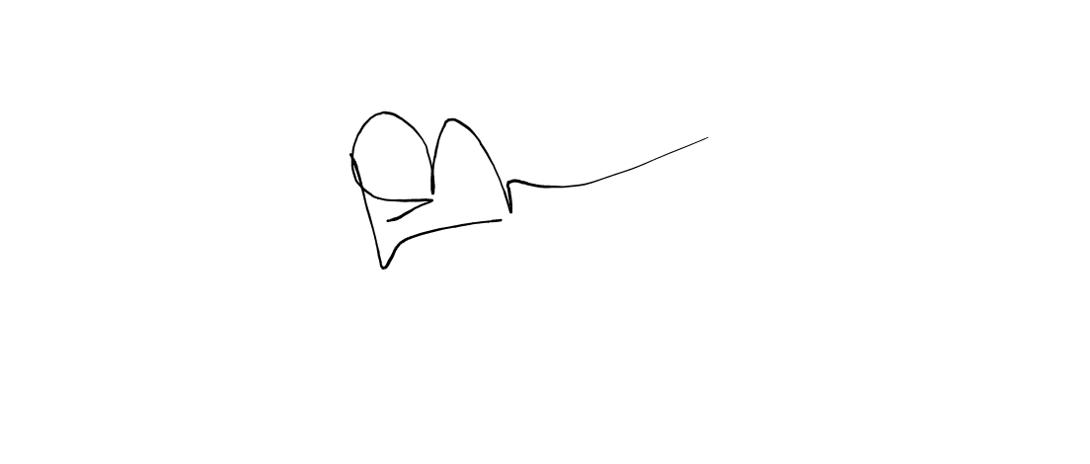
GILL GODLONTO&GERRANS, APPLICANT’S LEGAL PRACTITIONERS. CHATSAMA AND PARTNERS , PERSPONDETS’LEGAL PRACTITIONERS.

