IN THE LABOUR COURT OF ZIMBABWE

HARARE, 5 MARCH, 2024
07 MARCH 2024
JUDGMENT NO LC/H/96/2024 CASE NO LC/H/686/23

CHARLES NHERERA APPELLANT

CHINHOYI UNIVERSITY OF TECHNOLOGY RESPONDENT

Before the Honourable G. Musariri, Judge:

For Appellant - Mr T. Magwaliba, Advocate
For Respondent - Mr S. Mushonga, Attorney

MUSARIRI, J:

At the onset of oral argument in this Court the parties raised preliminary issues which shall be dealt with in turn.

Respondent
Respondent applied for condonation of belated filing of its response. It stated that the response was due on the 21st September 2023 but was filed one (1) day later on 22nd September 2023. The delay was caused by the fact that the respondent is based in Bindura whilst the Court is situate in Harare. No prejudice has been alleged or shown by appellant. All necessary papers now being available respondent argued that it was in the interests of justice that condonation be granted and the matter be determined on its merits.

Respondent then took the point that appellant’s notice of appeal was filed out of time. The arbitration award in issue was issued on 4th August 2023. Rule 19(1) of the Labour Court Rules
S.I. 150 of 2017 requires that appeals be brought within twenty-one (21) days of the impugned award. The appeal period lapsed on 6th September 2023. The appeal was filed on 7th September 2023. Thus it was filed one (1) day out of time. Therefore there is no valid appeal before this Court. Appellant not having applied for condonation, its appeal ought to be struck off the roll.

Appellant
Appellant argued that the application for condonation must be dismissed on 2 grounds. The response was filed on 18th October 2023 per the Labour Court’s stamp. The response was due on 21st September 2023. It was therefore filed almost one (1) month late. So respondent was required to apply for condonation but did not do so until today which is 5 months’ later. There is no explanation for the delay in seeking condonation. Appellant is prejudiced by being confronted with the application for first time at the hearing.
Appellant also argued that the cross-appeal is improperly before the Court. A cross-appeal must be filed within ten (10) days of the main appeal. Thus it should have been filed on 21st September 2023. It was filed one (1) day later on 22nd September 2023. No application has been made for its condonation. Therefore respondent’s cross-appeal ought to be struck off the roll. The net result is that appellant’s appeal stands unopposed and should be allowed on that basis.

Analysis
The arbitration award in question was issued on 4th August 2023. The main appeal was filed on 7th September 2023. The appeal period (twenty-one days) lapsed on 6th September 2023. It is apparently out of time by one day. Respondent argued that the appeal period is reckoned from date of receipt not the date of issue of the award. Indeed the Rule 19(1) references the date of receipt of the award. There is no indication on record of the relevant date of receipt. Rule 4(2) (c)
(i) covers such a situation thus

“(2). A person shall be deemed to have received-

(c). for the purpose of rule 19(1)-
(ii). a determination made under an employment code in terms of Section 101 of the Act, by the fourteenth day after the date indicated on that determination as the date of issue thereof;”

The main appeal in casu was filed within the fourteen day period after issue of the award. Therefore it was filed within time.
As shown above, the response to the main appeal was filed one month out of time. There is no indication as to when the respondent became aware of the expiry of the deadline for its response. Furthermore there is no explanation as to why the application for condonation was made 5 months’ later on the date of hearing of the matter. The explanation that respondent is based in Bindura and not Harare is rather colourless in light of the extended delays involved. On the other hand appellant stands prejudiced by being blind-sided by an oral application for condonation at the eleventh hour as it were. The interests of justice herein weigh against condonation. The Court is fortified in this view by the case of

Kodzwa v Health Secretary 1999(1) ZLR 313(5)
Per Sandura JA at 315 E-F
“It is, therefore, well established that the Court has a discretion to grant condonation when the principles of justice and fair play demand it; and when the reasons for non- compliance with the rules have been explained to the satisfaction of the court.”

Therefore the impugned response stands to be struck out of the record. That course inevitably collapses the cross-appeal. Rule 19(4) provides that

“(4) A person who wishes to make a cross-appeal shall do so at the same time as he or she files a notice of response in which event the provisions of these rules with regard to appeals shall apply, with necessary modifications, to the cross-appeal.”

Having filed an invalid response, it was not possible to file a cross-appeal compliant with Rule 19(4).

Wherefore it is ordered that,

- Respondent’s application for condonation of its belated response be and is hereby dismissed;

- Respondent’s response is struck out of the record;

- Respondent’s point in limine (invalid main-appeal) is dismissed;

- Appellant’s point in limine (invalid cross-appeal) is upheld;

- Respondent’s cross-appeal is struck out of the record; and

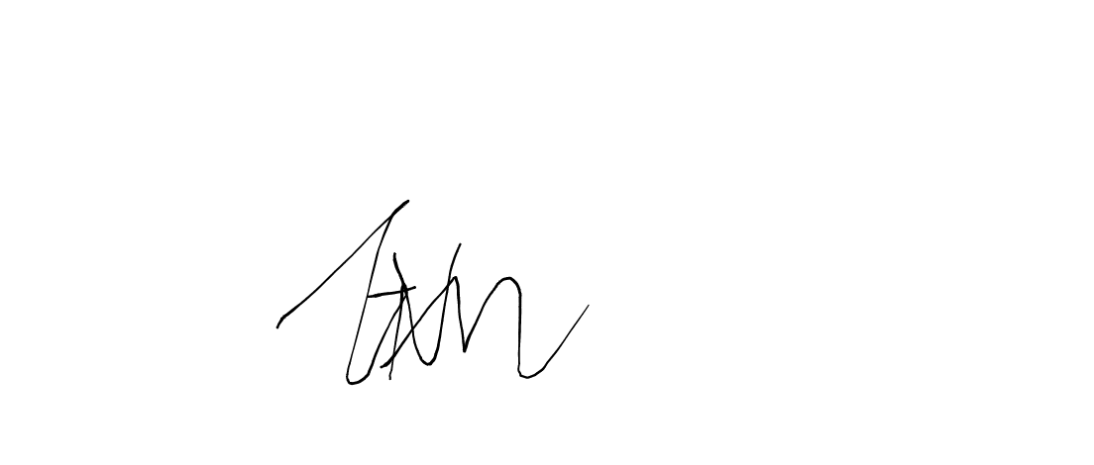
- The matter is postponed to the 21st March 2024 at 2:15pm for continuation.

G. MUSARIRI J-U-D-G-E

