CATRIONA STONE APPLICANT

And

COMMISSIONER T.W.R BARE N. O 1ST RESPONDENT

FLOYD MAPHOSA 2ND RESPONDENT

MINISTER OF LANDS, AGRICULTURE, FISHERIES 3RD RESPONDENT WATER, CLIMATE AND RURAL DEVELOPMENT

IN THE HIGH COURT OF ZIMBABWE

CHIVAYO J

BULAWAYO, 21 March 2025, 24 June 2025.

Application for Review I.T.O Rule 62

B.Z. Mlilo, for the Applicant
No appearance for the Respondents

CHIVAYOJ: The introduction of the Land Reform Program in Zimbabwe was monumental in the history of Zimbabwe. It brought about everlasting changes with far reaching effects. On the one hand, jubilation and satisfaction to those who had long advocated for it, on the other, a sense of ‘injustice’ and fear of what was to come to those who held of humongous pieces of land. A neutral look into the Land Reform program shows that such a move may have been necessitated by the need to repair injustices of the past, and a need to balance the economic and social standing of the general Zimbabwean population. This was the purpose of the Land Reform Programme as established in the former Constitution of Zimbabwe, 1980 (hereafter “the former Constitution”).
- Before this court is an application for a review of a decision by the Zimbabwe Land Commission against the Applicant, on the basis that the Commission’s decision was ‘grossly

irregular’. This results from a decision by the Zimbabwe Land Commission to issue out an offer letter to the second Respondent in this case, with the effect that part of what the Applicant views as its land, was offered to the Second Respondent. This was viewed as grossly irregular, mainly because the Commission, as it is understood from the Applicant’s point of view, erred in upholding a decision that was made by the District Administrator, Umzingwane Rural District Council, which is a subsidiary of the Ministry of Lands, Agriculture, Fisheries, Water, Climate and Rural Development, the third Respondent in this case. The Applicant states that the issuance of an offer letter to the second Respondent by the District Administrator was beyond the scope of their powers, and that there was a grossly irregular error on the part of the Land Commission, which has the powers to issue offer letters, in upholding such offer.

Factual background.

- The Applicant in this matter was the owner of a farm named High Acres Farm, situate in Esigodini, and measuring 568,523 hectares. The farm was acquired by the State in 2001 under the Land Acquisition Act [Chapter 20:29] (herein after the Land Acquisition Act). There is no issue as to the lawfulness of the acquisition of the farm. It is alleged that the District Administrator, Umzingwane Rural District Council purportedly allocated portions of the farm, and one portion was allocated to the second Respondent. It was also established by the Applicant that the Second Respondent had taken occupation of the farm and was subsequently evicted in 2004. Having made representations to the Third Respondent, who is the acquiring authority, the Applicant was issued with an offer letter dated 14 January 2005.
- The Applicant approached the Esigodini Magistrates Court in 2007 seeking an Interdict against the Second Respondent, which was granted, and remains extant. The Second Respondent approached this Honourable Court in 2008 under case number HC 637/08 alleging that the Applicant was in unlawful occupation of the farm, assuming that this was the portion which the Second Respondent had been offered. The Application was however, withdrawn just before the matter could be heard. The Second Respondent then approached the Zimbabwe Land Commission based on the same allegations as those raised before the High Court, seeking a determination of his irregular eviction from the farm. The issue for determination before the Commission was whether the Applicant was in lawful occupation of the farm, and whether the Second Respondent in this matter had a valid offer.
- The Zimbabwe Land Commission then held a hearing between the two parties, with the Commission holding that the Second Respondent had a valid offer, and that the Applicant’s offer

be withdrawn and she be reissued with one to the effect that she remains with four subdivisions of the High Acres Farm, with the 5th subdivision being offered to the Second Respondent.
- It is the Applicant’s contention that the Commission’s ‘decision…was grossly irregular in that he upheld a decision that was made by the District Administrator in excess of the District Administrator's powers.’ It is contended by the Applicant that the Commission upheld an ultra vires decision of the District Administrator, a subsidiary and extension of the Ministry mandated to issue offer letters
Point in limine

- On the day of hearing, the court mero motu raised the question of the jurisdiction of this court to hear the Application for Review in terms of Rule 62 of the High Court Rules, 2021. Since the Respondents were barred for failure to file their opposing papers within the dies inducia, the court heard submissions from the Applicant only.
- In response to the issue raised by the court, the Applicant submitted that this court has jurisdiction to review the decision of the Commissioner of the Zimbabwe Land Commission in terms of section 171(1)(b) of the Constitution. Section 171 (1) and ss (2) reads as follows:
“(1) The High Court—

  - has original jurisdiction over all civil and criminal matters throughout Zimbabwe;

  - has jurisdiction to supervise magistrates courts and other subordinate courts and to review their decisions;

  - may decide constitutional matters except those that only the Constitutional Court may decide; and

  - has such appellate jurisdiction as may be conferred on it by an Act of Parliament.

(2) An Act of Parliament may provide for the exercise of jurisdiction by the High Court and for that purpose may confer the power to make rules of court.”

- The Applicant also submitted that section 3 of the Gazetted Land (Consequential Provisions) Act [Chapter 20:28] (hereafter the Gazetted Land Act) gives this court jurisdiction to hear the Application for Review. In terms of section 3 of the Gazetted Land Act, a court can convict and fine a person who contravenes the provisions of the Act. This section speaks of a person who is found to be in unlawful occupation of Gazetted Land. However, based on the facts before this court it is clear that no person has been found to be in unlawful occupation of gazetted land and as such the provision referred to by the Applicant is not applicable in this matter.

- The Applicant also submitted that this court has jurisdiction to hear the matter in terms of section 26 and 27 of the High Court Act [Chapter 7:06]. Section 26 of the High Court Act reads as follows:

“Subject to this Act and any other law, the High Court shall have power, jurisdiction and authority to review all proceedings and decisions of all inferior courts of justice, tribunals and administrative authorities within Zimbabwe.”

- This section is of great importance as it relates to the jurisdiction of the High Court to potentially review decisions from tribunals and administrative authorities within Zimbabwe. Section 27 of the High Court Act further goes on to set out the grounds for review. These grounds are that:

“(1) Subject to this Act and any other law, the grounds on which any proceedings or decision may be brought on review before the High Court shall be—

  - absence of jurisdiction on the part of the court, tribunal or authority concerned;

  - interest in the cause, bias, malice or corruption on the part of the person presiding over the court or tribunal concerned or on the part of the authority concerned, as the case may be;

  - gross irregularity in the proceedings or the decision.

(2) Nothing in subsection (1) shall affect any other law relating to the review of proceedings or decisions of inferior courts, tribunals or authorities.”
- The Applicant brought this Court Application for Review in terms of Rule 62 of the High Court Rules which provides for Applications for Reviews from “…inferior court or of any tribunal, board or officer performing judicial, quasi-judicial or administrative functions…” This Application is a review of a decision made by the Zimbabwe Land Commission. It is of paramount importance to note that the Zimbabwe Land Commission is established in terms of the Land Commission Act [Chapter 20:29] (hereafter “the Land Commission Act”). Section 61 of the Land Commission Act provides as follows:

“(1) Subject to this section, any person who is aggrieved by—

  - the decision of, or action or lack of action on the part of, the Commission upon any dispute or complaint; or

  - such decision or action of the Commission as may be prescribed; may, within twenty-eight days after being notified of the decision or action of the Commission concerned, appeal in writing

to the Minister, submitting with his or her appeal such fee as may be prescribed, and such appeal shall suspend the operation of any decision issued by the Commission.”(Emphasis added)

- Section 61(4) of the same Act goes on to provide that “an aggrieved party may seek judicial review of any decision of the Minister on an appeal affecting him or her”.
- Section 171(b) of the Constitution provides for the extent and limits of the power of the High Court in dealing with the broad rights enshrined in section 171 of the Constitution, giving this court jurisdiction to review proceedings. Section 26 of the High Court Act echoes s 171(1)(b) of the Constitution, vesting the High Court, as it does, with the extensive power to exercise its review function. None of the parties raised the issue of whether this Review is properly before the court. It will insinuate that the Applicant is relying on the wide powers of High Court on review to determine the matter. However, that is not the standing of the law. It was held in Sergeant Khauyeza v The Trial Officer & Anor HH 311/18 at page 17 that:
“It defies logic, that in creating the right to approach the High Court, the legislature intended a party to willy nilly forego elaborately provided local remedies and approach the High Court in circumstances where there is no challenge as to the accessibility and availability of those local remedies. It could not have possibly been the intention of the legislature that a party should ignore the principle that a local remedy which is available, effective, sufficient and not unduly prolonged should be overlooked perhaps because it is unattractive, inconvenient or does not produce a favourable result, and in the process create an onerous burden on the High Court.”
- A similar matter as decided by our courts was in Girjac Services (Pvt) Ltd v Mudzingwa
1999(1) ZLR 243(S) at 249 C – F, where Gubbay CJ, as he then was, stated:

“In Tutani v Minister of Labour and Others 1987 (2) ZLR 88(H) at 95D, Mutambanengwe J observed that where domestic remedies are capable of providing effective redress in respect of the complaint and secondly, where the unlawfulness alleged has not been undermined by the domestic remedies themselves, a litigant should exhaust his domestic remedies before approaching the courts unless there are good reasons for not doing so.”
- These above-mentioned cases clearly show the importance of exhausting local remedies, or domestic remedies as they are called. It is important to note that these domestic remedies include bodies with the most appropriate expertise, people with the relevant experience and qualifications for the particular issue in dispute, and are always the people best placed to deal with the disputes. Our courts do not have the necessary expertise to deal with issues which can always be dealt with through use of domestic remedies. As such, courts are slow to interfere with these disputes when the local remedies have not been exhausted.

- It is apparent from the given set of facts that, while the parties had issued a complaint to the Commission and the Land Commission made a decision, no aggrieved party appealed to the Minister, as provided for in terms of section 61(1)(b) of the Land Commission Act. This court is of the view that the Applicant did not exhaust the local remedies, as she ought to have appealed the decision of the 1st Respondent to the Minister, who is the 3rd Respondent in this case. What the Applicant should have done is to file an Appeal with the Minister within twenty-eight days of the decision of the Zimbabwe Land Commission. It is established that there was no such appeal. The Applicant must therefore exhaust the domestic remedies available to her before approaching this court for redress.

Disposition

- In light of the above, this court finds that this Application is improperly before it. The matter is therefore struck off the roll.

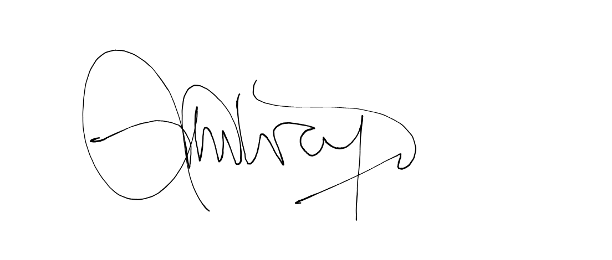
Webb Low & Barry incorporating Ben Baron & Partners Applicant’s Legal Practitioners.

CHIVAYO J…………………………………….

