IN THE LABOUR COURT OF ZIMBABWE HELD AT HARARE 20TH MARCH 2024

In the matter between

BRIAN NKIWANE
And

CHEGUTU MUNICIPALITY

BEFORE THE HONOURABLE MAKMURE JUDGE.

JUDGMENT NO. LCH121/24
CASE NO. LC/H/703/23

APPELLANT

RESPONDENT

FOR THE APPELLANT : MR K. M. CHIRENJE (LEGAL PRACTITIONER) FOR THE RESPONDENT : MR T. S. MUSUNDIRE( LEGAL PRACTITIONER)

MAKAMURE J:

This is an appeal against the dismissal of Appellant from Respondent’s employ. There are eight(8) grounds of appeal . Out of those 8 grounds the parties agreed that with respect to the first four grounds they will abide by papers filed of record and oral argument will be restricted to grounds 5to7.As usual following the grounds is the prayer. The prayer reads:
‘WHEREFORE the Applicant prays for an Order for the setting aside of the Disciplinary Authority’s decision.’

Preliminary Issues

Two preliminary issues were raised on behalf of the respondent. These are that(i) the notice of appeal is fatally defective ;and (ii) the appeal was filed out of time , is not properly before the Court and should therefore be struck off the roll.
- The Prayer is fatally defective.

The argument on behalf of the respondent was that the notice of appeal is fatally defective in that it does not state the exact relief that the appellant is seeking. The question that was asked on behalf of the respondent was : should the decision be set aside , then what next? The Court was referred to authorities which include Ndlovu v Ndlovu & Anor SC133/02; Jensen v

Acavalos 1993(1) ZLR 216(S).It was argued that the prayer is incurably defective. For that reason, it was submitted that the appeal must be struck off the roll.
In response Mr Chirenje who appeared on behalf of the appellant argued that the prayer was not defective. He argued that the respondent is trying to hide behind technicalities in order to avoid the merits. He submitted that labour matters ought to be determined on the merits.
It is trite that in a notice of appeal the prayer must be exact. In Christopher Sambaza v Al Shams Global BVI Limited SC03/18 the Supreme Court stated that a fatally defective prayer which does not state the exact nature of the relief sought cannot be amended. In Sarah Ndlovu and Another v Moffat Ndlovu and Another SC 133/02 the Supreme Court stated that:
‘The exact nature of the relief sought was not stated. What was prayed for in the notice of appeal was that the judgment of the court a quo be dismissed with costs. It is the appeal which is dismissed or allowed. If the appeal is allowed the judgment or decision appealed against is then set aside and a new order substituted in its place. In this case it was not known what order the appellants wanted this Court to make in the event the appeal succeeded.’
In the present matter it is also not known what order the appellant wants this Court to make. It is not up to the Court to decide what should happen in the event that the appeal succeeds. The appellant must say in exact terms what order the Court should make. I therefore entirely agree with Mr Musundire who appeared on behalf of the respondent, that the prayer is fatally defective. I can do no better than refer to what Malaba JA (as he then was ) in the Ndlovu case (above).This is what the learned Judge of Appeal said:
‘With this view I most respectfully agree; for if the notice of appeal is incurably bad, then, to borrow the words of LORD DENNING in Mcfoy v United Africa Co Ltd [1961] 3ALL ER 1169(PC) at 1172,”every proceeding which is founded on it is also bad and incurably bad. You cannot put something on nothing and expect it to stay there. It will collapse.
As the notice of appeal which purported to institute this appeal was incurably defective, there was no appeal before the Court.’”
The present appeal is fatally defective. There is no appeal before the Court. The preliminary issue has merit. It is upheld. The matter can only be struck off the roll.

- The Appeal was filed out of time

The appellant appeared before the respondent’s Disciplinary Authority facing three charges , that is, Non -compliance with established standing instructions /policies/regulations and financial regulations; Misuse of Council property and Misappropriation of donated goods.
These were all violations of the respondent’s code of conduct.

At the conclusion of the disciplinary hearing the appellant was found guilty of the first two offences and was acquitted on the third charge. He was penalized with dismissal. The decision of the Disciplinary Authority is dated 23rd May 2023.The appellant was aggrieved by that decision and he appealed internally. On 21 July 2023 the respondent’s Appeals Committee considered the appeal. It dismissed the appeal and upheld the decision of the Disciplinary Committee. On 13th September 2023the present appeal was noted.
The contention on behalf of the respondent is that the appellant was served with the determination from the Disciplinary Authority on 27th May 2023. In the notice of appeal appellant says they were served with the decision on 7th August 2023.It was argued that whether the date of receipt of the decision is the 27th of May or 7th August 2023, the appeal was still noted out of time. Mr Musundire argued that the provisions of Rule 19 of the Rules of this Court Statutory Instrument 150 of 2017 which deal with appeals are peremptory. This Mr Musundire submitted, means that the appellant was obliged to comply with those provisions. Failure to comply with the said provisions it was argued, means that the appeal is not properly before the Court and must be struck off. The position of the appellant on the other hand is that the preliminary point should be dismissed . It was argued that they were served with the decision on the 7th of August 2023 and appeal having been noted on 13th September 2023, the delay of five days is not inordinate and the Court should condone it so that merits of the case can be considered. In reply Mr Musundire insisted that the appellant did not purge his non -compliance through an application for condonation . As such therefore the submission remained that the appeal being out of time, it is not properly before the Court.
Rule 19 provides for appeals and cross appeals as follows:

“19. Appeals and cross appeals

  - A person wishing to appeal against any decision, determination or direction referred to in the Act, shall,

within twenty-one days from the date when the appellant receives the decision, determination or direction or award,
do the following—

    - complete in three copies a notice of appeal in Form LC 4; and

    - make three copies of any of the documents referred to in subparagraphs (i) to (iv) as are relevant to the
appeal, if they are in the possession of the appellant—

- the record of any charge or allegation of misconduct that was served on the appellant, if any;
- the minutes or record of any proceedings or hearing undertaken to inquire into any charge against or
allegation of misconduct on the part of the appellant;

- a minute or record of any decision, determination, direction or award made at the conclusion of any
proceedings or hearing referred to in subparagraph (ii);

- the letter of suspension or dismissal from employment, if any;

    - deposit with the Sheriff an amount to be determined by the Sheriff as security for costs of service of the notice
of set down.

    - file with the Registrar one of the other copies of the notice of appeal, together with—

(i) a copy of the documents, if any, referred to in paragraph (b);...”( Emphasis added).

The Rules require the litigant to note the appeal within twenty-one days. As correctly submitted on behalf of the respondent, the rule uses the word ‘shall’ which is peremptory. The rule does not give the person an option. Failure to comply means that the litigant is not properly before the Court. In order to be compliant, the appellant ought to have made an application for condonation. It is appreciated that the delay in noting the appeal was five days. While it may appear not to be inordinate, it does not mean that the Court can just condone the delay at the appellant’s mere asking. The appellant must follow the appropriate

procedure in order for the delay to be condoned. It is an established principle in this jurisdiction that it is not desirable for labour matters to be resolved on the basis of technicalities. The principle provides that technicalities are not ignored. They are corrected and then the court proceeds to deal with the merits. Dalny Mine v Banda 1999 (1) ZLR 220. There is a tendency by litigants to refer to this principle only in part and leave out the portion that requires correction of any technicalities that may interfere with the consideration of the merits. That tendency must be discouraged. Parties must comply with the rules of court. In Chikura N.O.& Anor v Al Sham’s Global BVI Limited SC 17/2017 the Supreme Court stated that rules are made for the proper running of the Court and that failure to comply with mandatory provisions will render an appeal a nullity. In the present matter it is common cause that the appellant delayed in noting the appeal by at least five days. There was no application for condonation to cure the delay. Since the provision is peremptory it mandates the party to comply. Non -compliance means that the matter is not properly before the Court. I therefore find that there is merit in the preliminary point raised. It is upheld.
I have found that both preliminary issues raised on behalf of the respondent have merit. Both preliminary issues have been upheld. This matter is not properly before the Court. Since the appeal is not properly before the Court, the merits will not be considered.
In view of the foregoing it is ordered that :

1.The appeal be and is hereby struck off the roll. 2.There is no order as to costs.

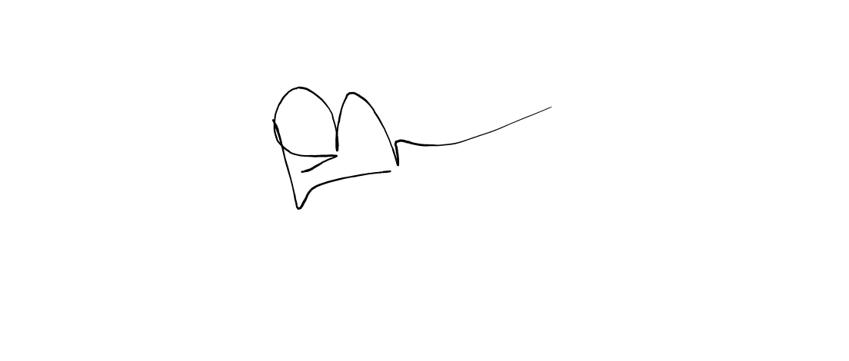
CHIRENJE LEGAL PRACTITIONERS, APPELLANT’S LEGAL PRACTITIONERS. WARARA AND ASSOCIATES, RESPONDENT’S LEGAL PRACTITIONERS

